TASK-2
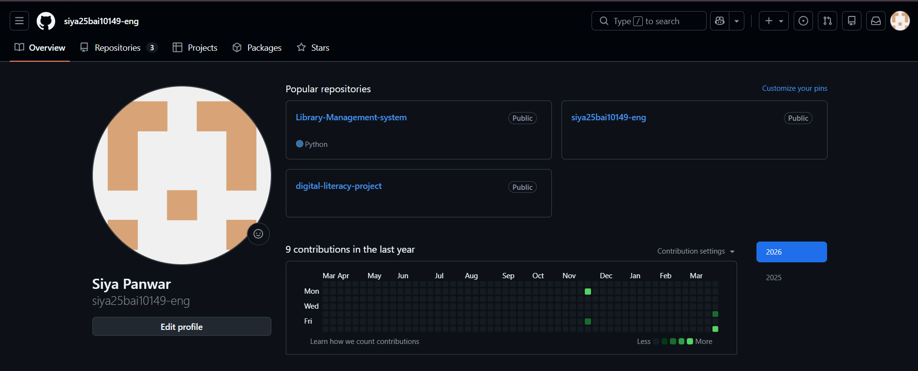
GITHUB PROFILE:

STACKOVERFLOW: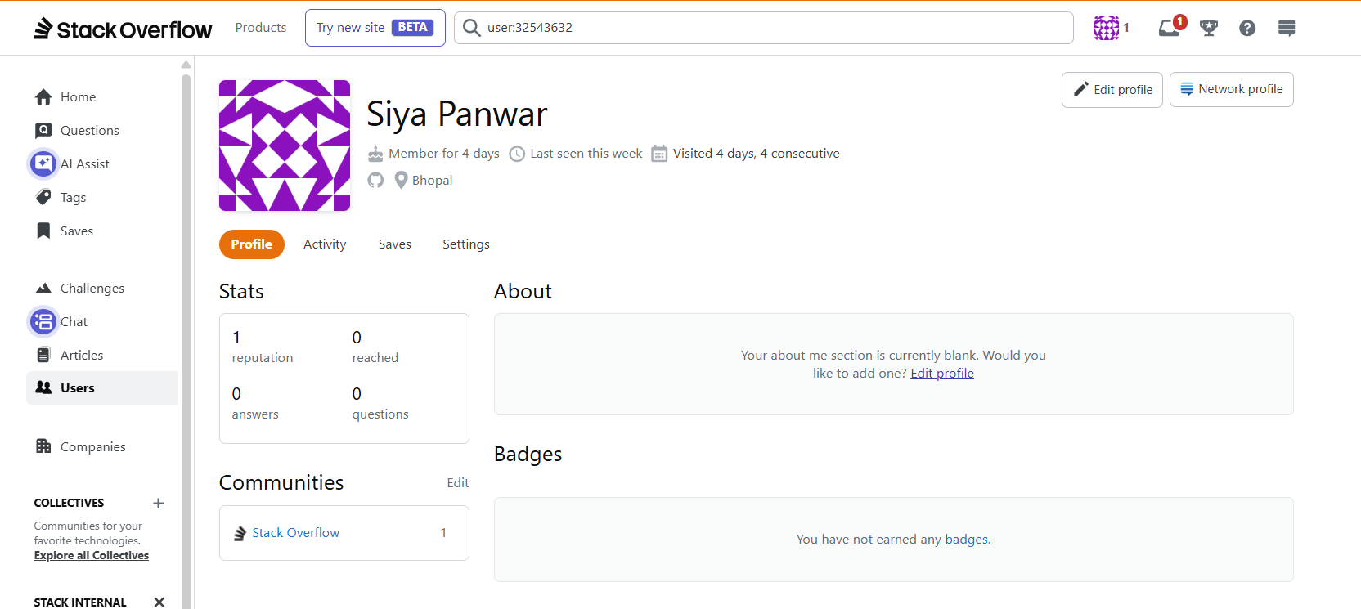

RESEARCHGATE:
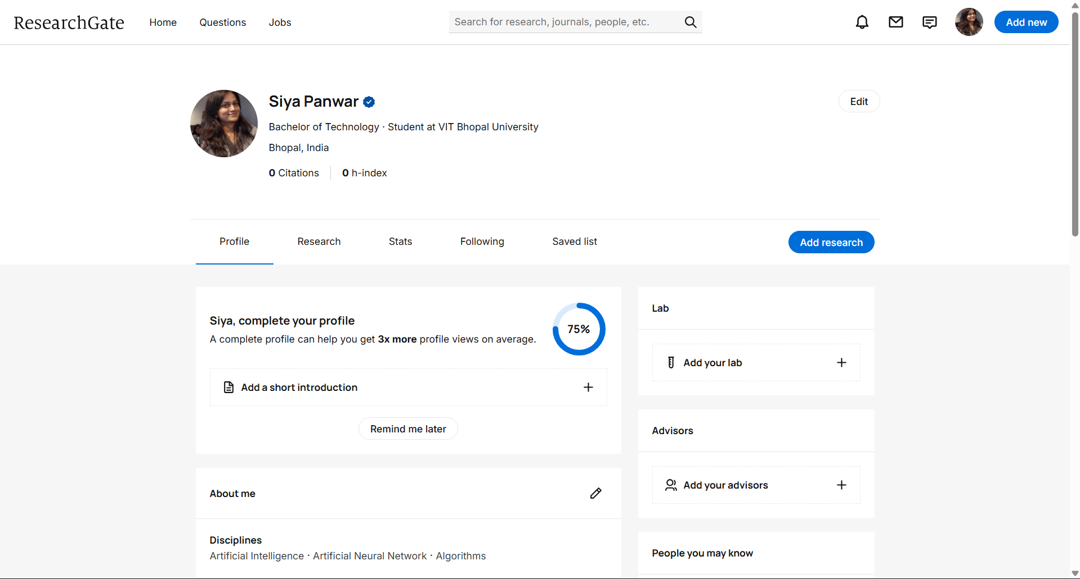
LINKEDIN: 
GitHub Repository Link:
https://github.com/siya25bai10149-eng/siya25bai10149-eng

